Bug Screenshots

- SWAG-001: No search bar in inventory page

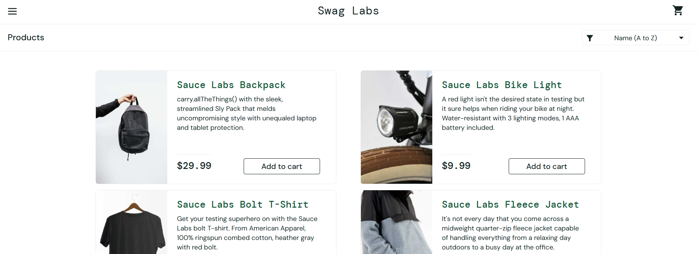
Bug_SWAG_001_No_Search_Bar.png

- SWAG-002 Cannot adjust quantity in cart

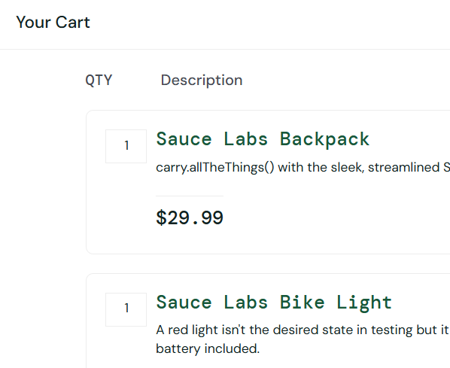
Bug_SWAG_002_No_Quantity_Adjust.png

- SWAG-003 No total cost in cart summary
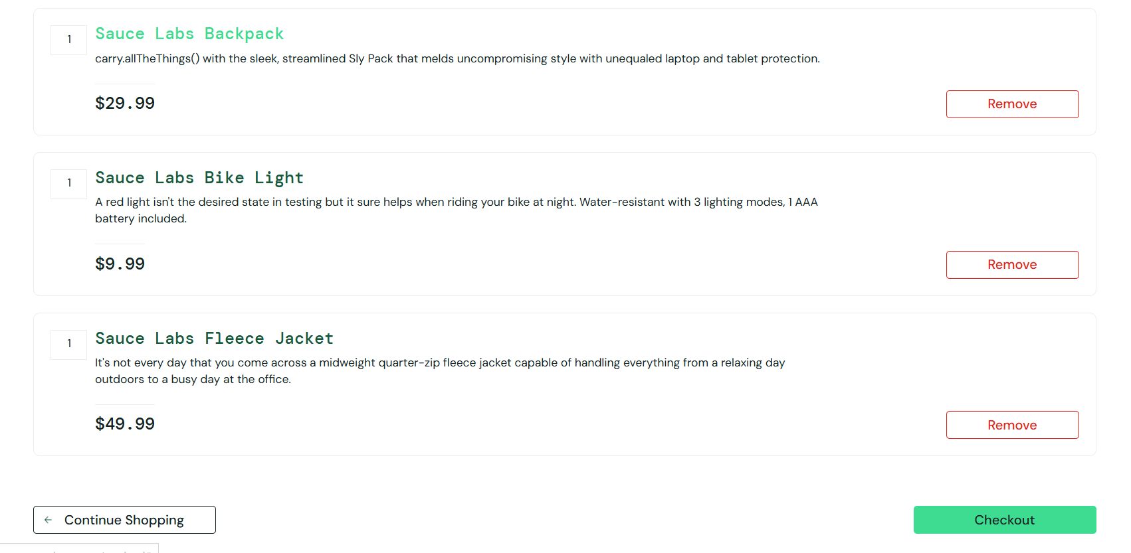
Bug_SWAG_003_No_Total_Cost.png
- SWAG-004 No ZIP/postal code validation
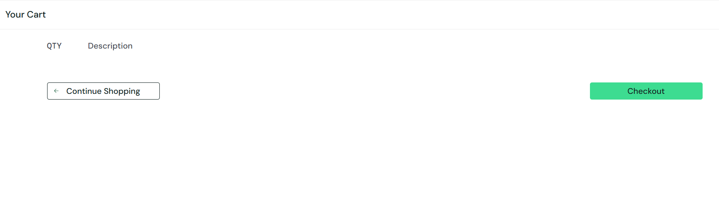
Bug_SWAG_004_No_Zip_Code_Validation.png

- SWAG-005 No "Out of stock" label
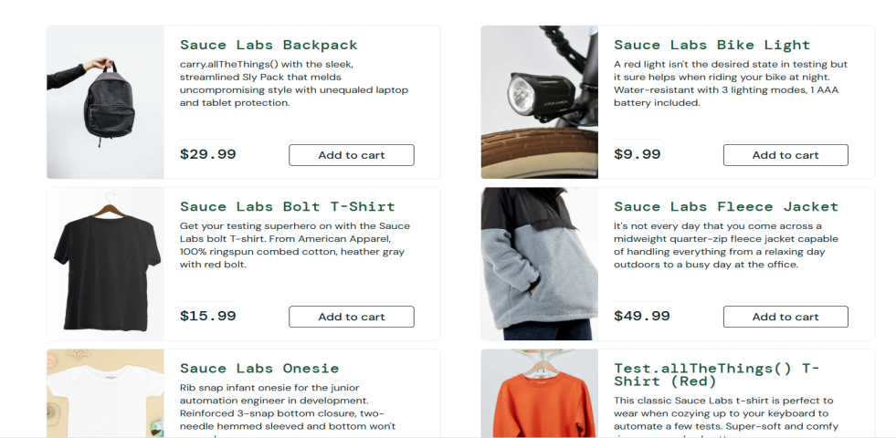
Bug_SWAG_005_No_Out_of_Stock.png

- SWAG-006 Empty cart message missing

Bug_SWAG_002_Empty_cart_Message_missing.png

